Module 2.2 Assignment
Simpson, Gabrialle
Bellevue University, CSD325-T301 Advanced Python (2265-1)
Spring 2026

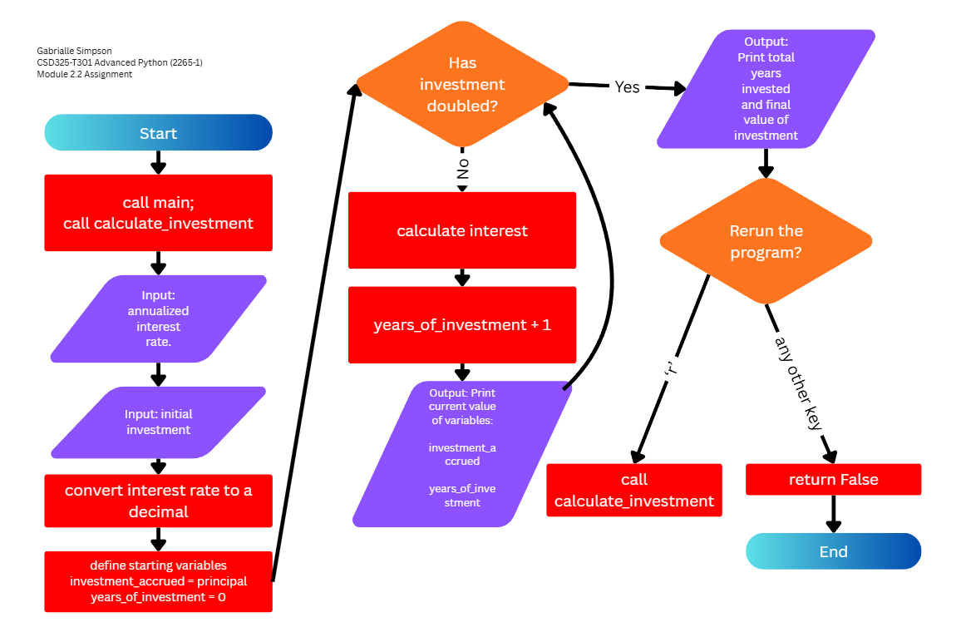
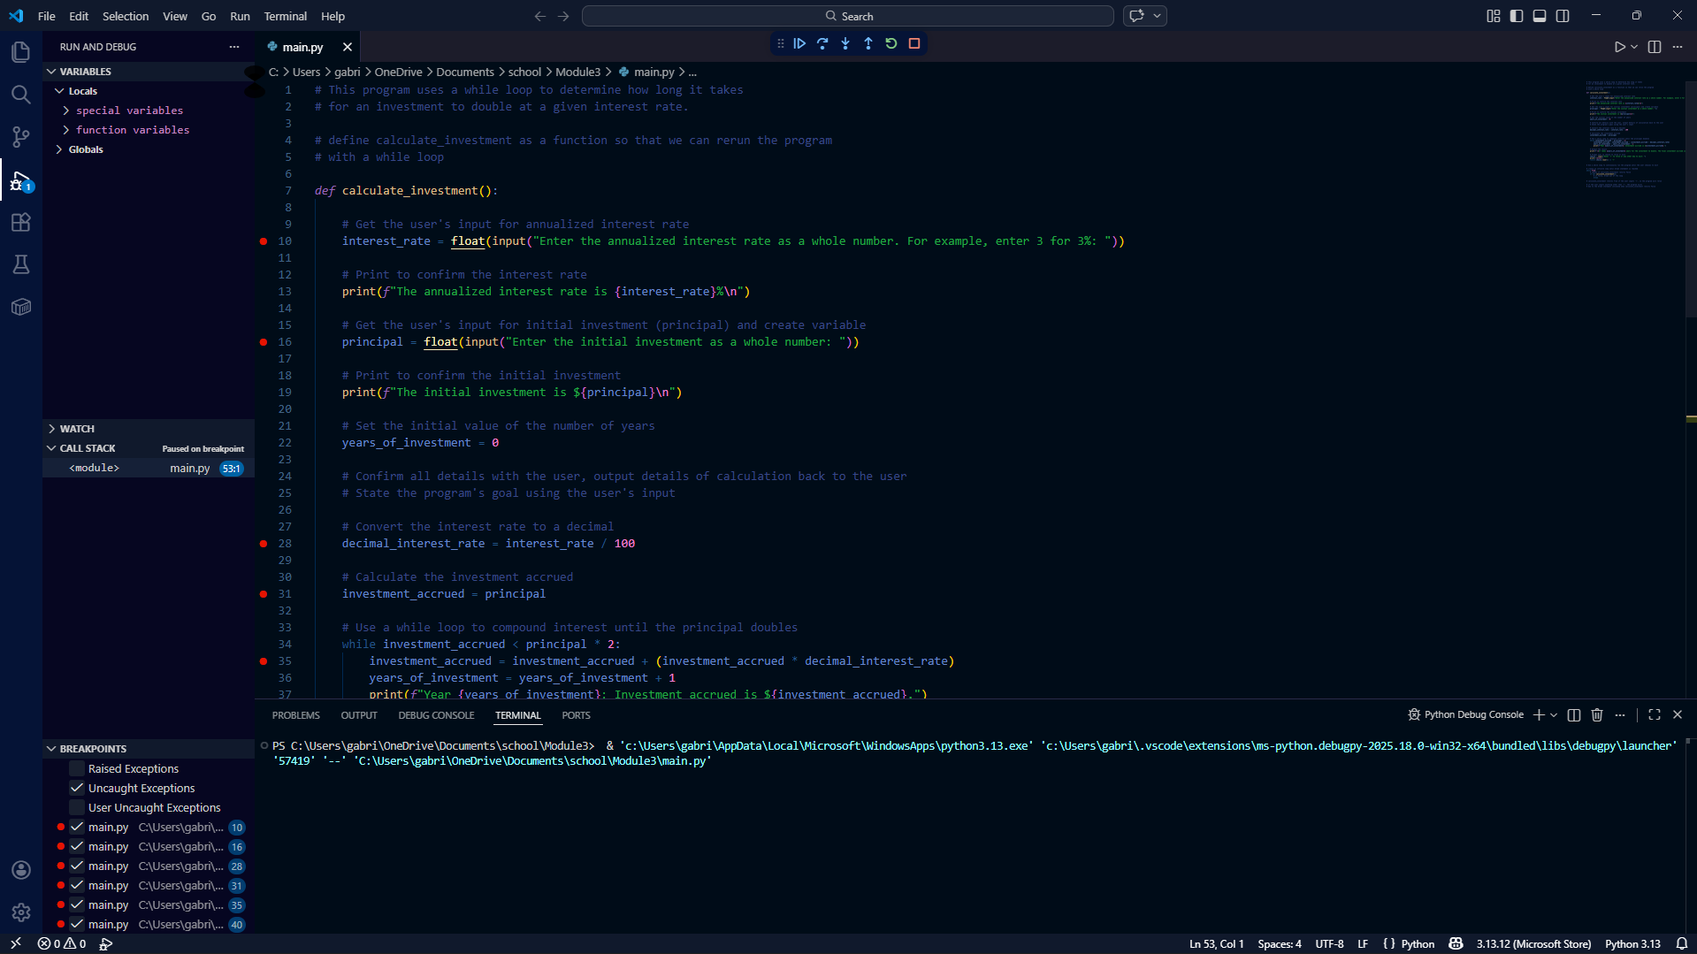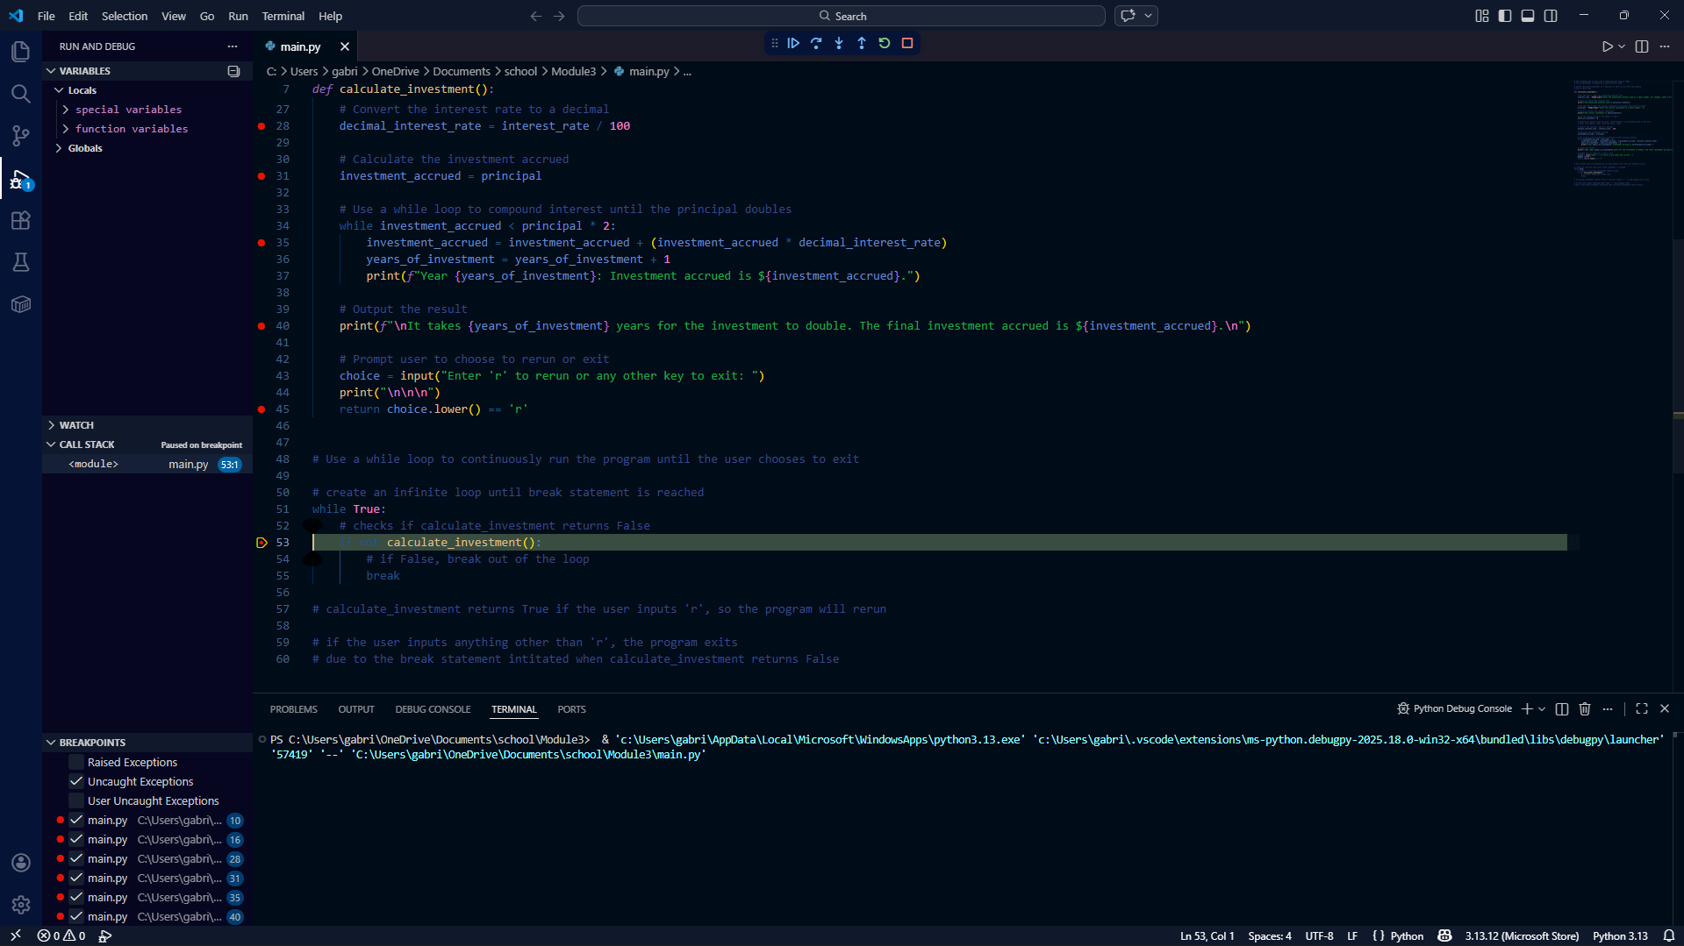
Above are the program breakpoints I used for debugging.

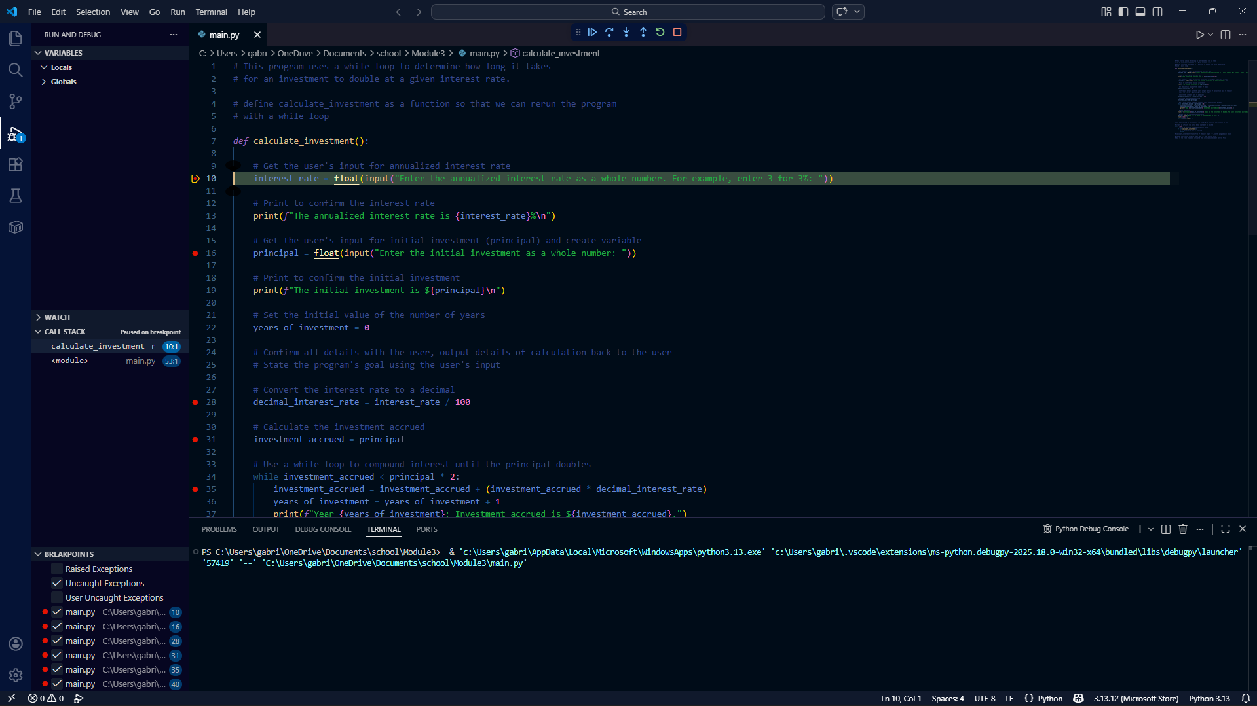
Stepping into the function.

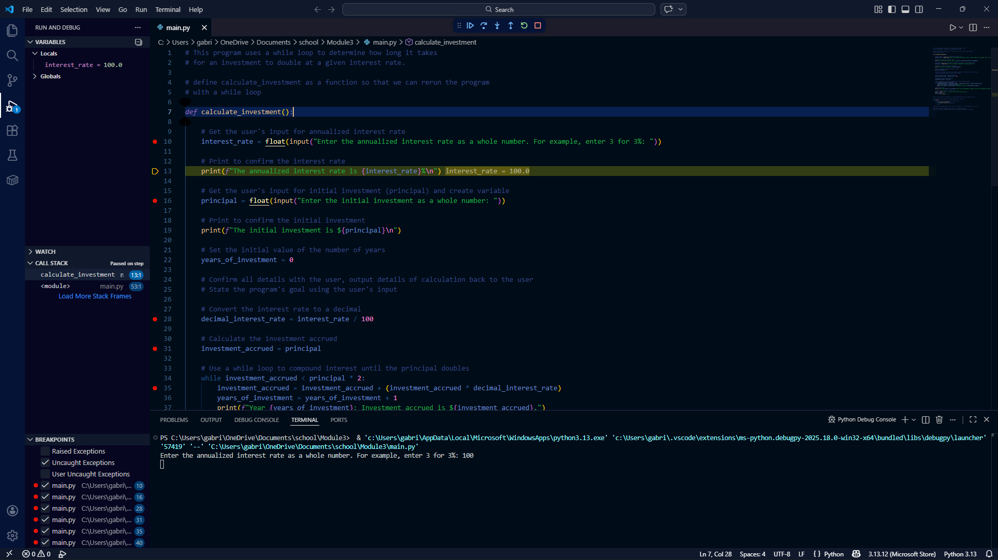
Upon entering a variable that is successful.

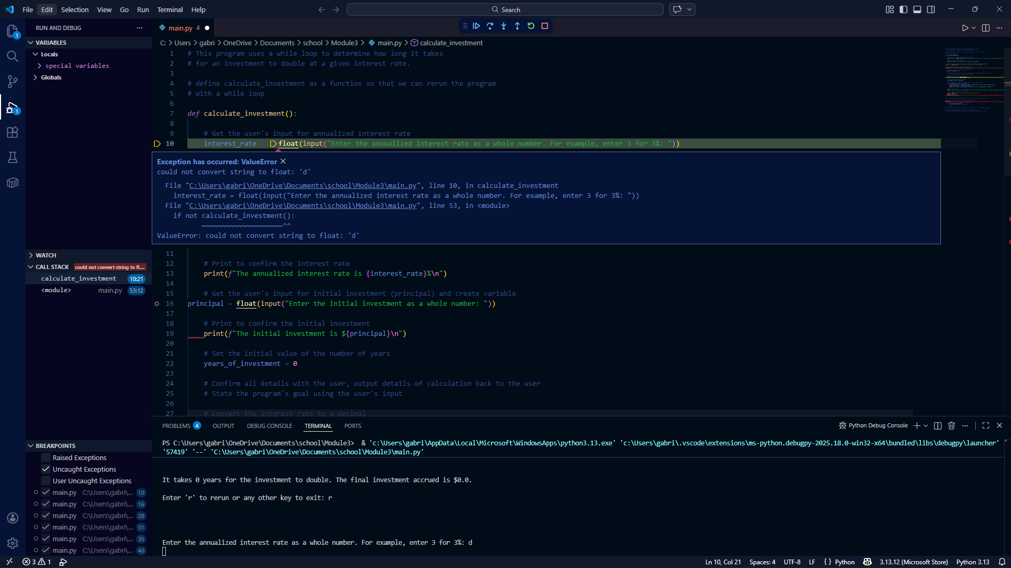
ValueError is due to user input exception. Code does not sufficiently guide user input and fails upon incorrect user input.
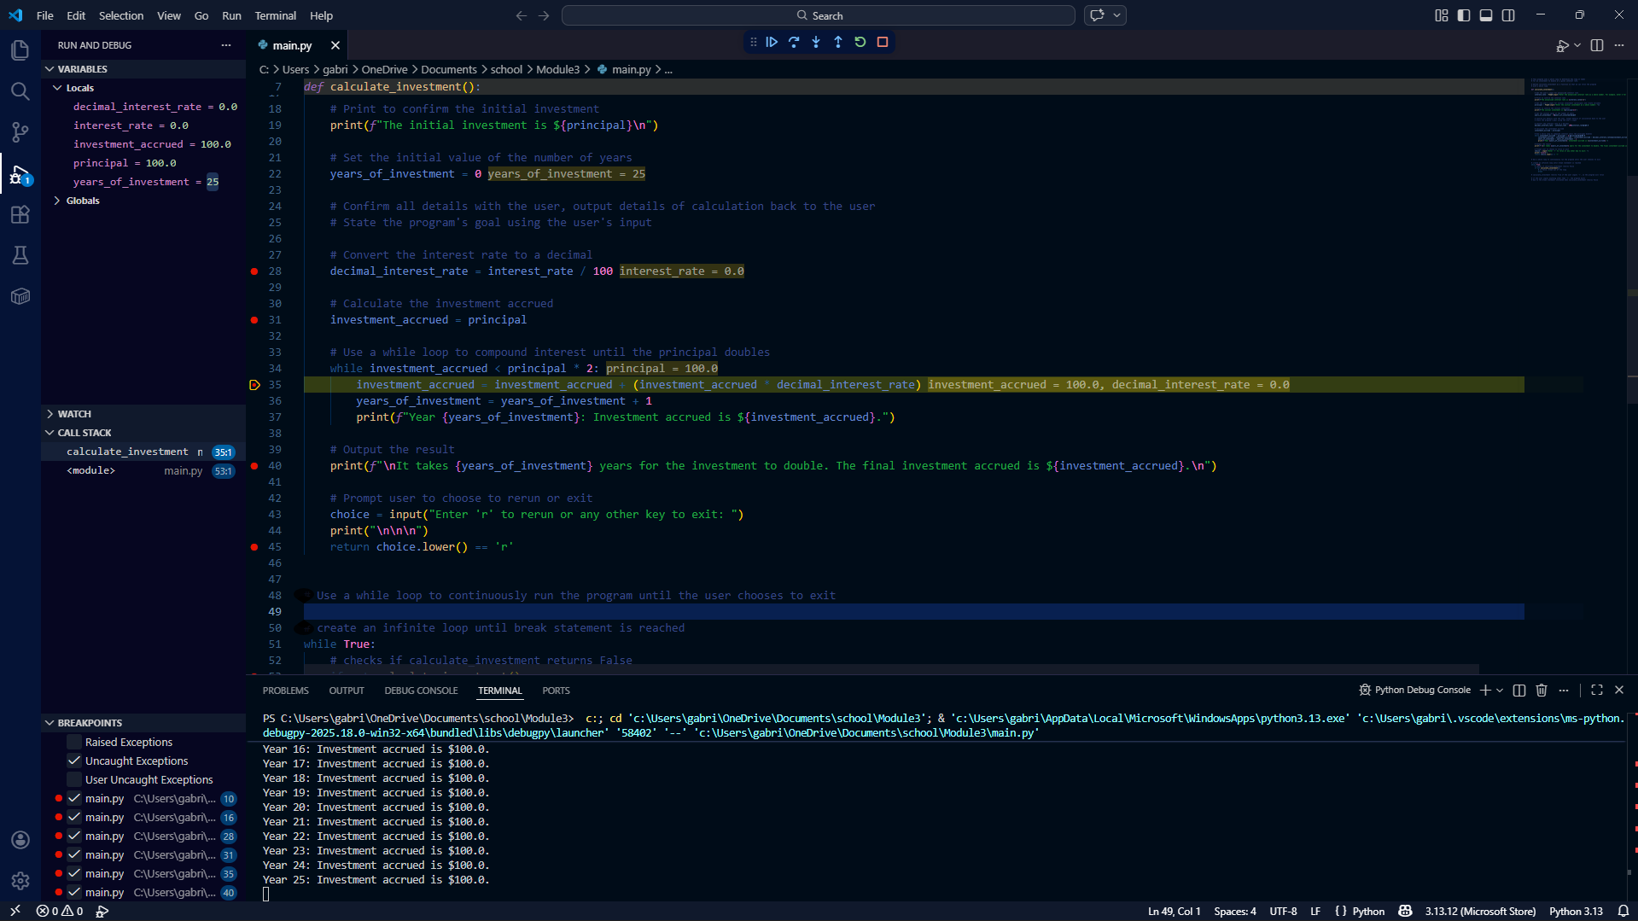
If interest is 0 the program creates an infinite loop due to division by 0. The while loop is infinite because ‘investment_accrued < principal * 2’ will never be untrue while the interest_rate is 0.

